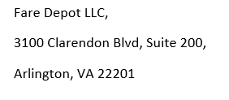

DATE:
I* hereby authorize FareDepot Travel, to charge this Credit Card for the purpose of paying for travel services, including air tickets, travel related charges and service fees.
Card Type* (Visa, American Express, Master Card, Discover)
Card Number*
Card Expiration* (MM/YY)
CVV Verification Code* (*3 or 4 digit Code)
Card Holder’s Name*
Full Name of Passenger(s)*
Authorized Amount $*
Billing Address*
Billing Phone Number*
Email*

Agreement*
I/we authorize FareDepot Travel to charge my credit card electronically without my signature, all travel related services, including but not limited to service fees, cancellation penalties and surcharges. I agree to pay all the charges as they appear on my credit card statement. Before disputing any charges, I hereby agree to contact FareDepot Travel to clarify the charges and check the status of any impending credits and voids. Please be aware that airline/vendor charges do appear instantly on your account while credits and voids may take up to four weeks. This is due to the nature of how airlines settle through the Airline Reporting Corporation (ARC), the clearing house that processes all credit card payments. Submitting this profile represents your agreement to pay all your credit card charges/invoices.
I Agree:*

Sincerely,
FareDepot.com Authorization Department
Email: sales@faredepot.com
Toll-Free: 866-860-2929

